# *SQL Murder Mystery*

## Can you find out whodunnit?

**About:** This document contains SQL codes used to solve the murder mystery puzzle published on <https://mystery.knightlab.com/>. The SQL Murder Mystery was created by Joon Park and Cathy He, who designed it as a self-directed lesson to learn SQL concepts and commands.

The assignment is done via a credited course in college under our professor Mr. Abdul Majed Raja.



Source: Knight lab

**By:** Esha Dinakaran Nair

eshadnair2001@gmail.com

**Information provided:** A crime has taken place, and the detective needs your help. The detective gave you the crime scene report, but you somehow lost it. You vaguely remember that the crime was a ​murder​ that occurred sometime on ​Jan.15, 2018​, and that it took place in ​SQL City

**SOLUTION PROCESS**

**1)Use case -** Preliminary look at the data and understand what the crime report mentions about the murder.

**Query -**

select *

from crime_scene_report

where date = 20180115 AND type = "murder" AND city = "SQL City"

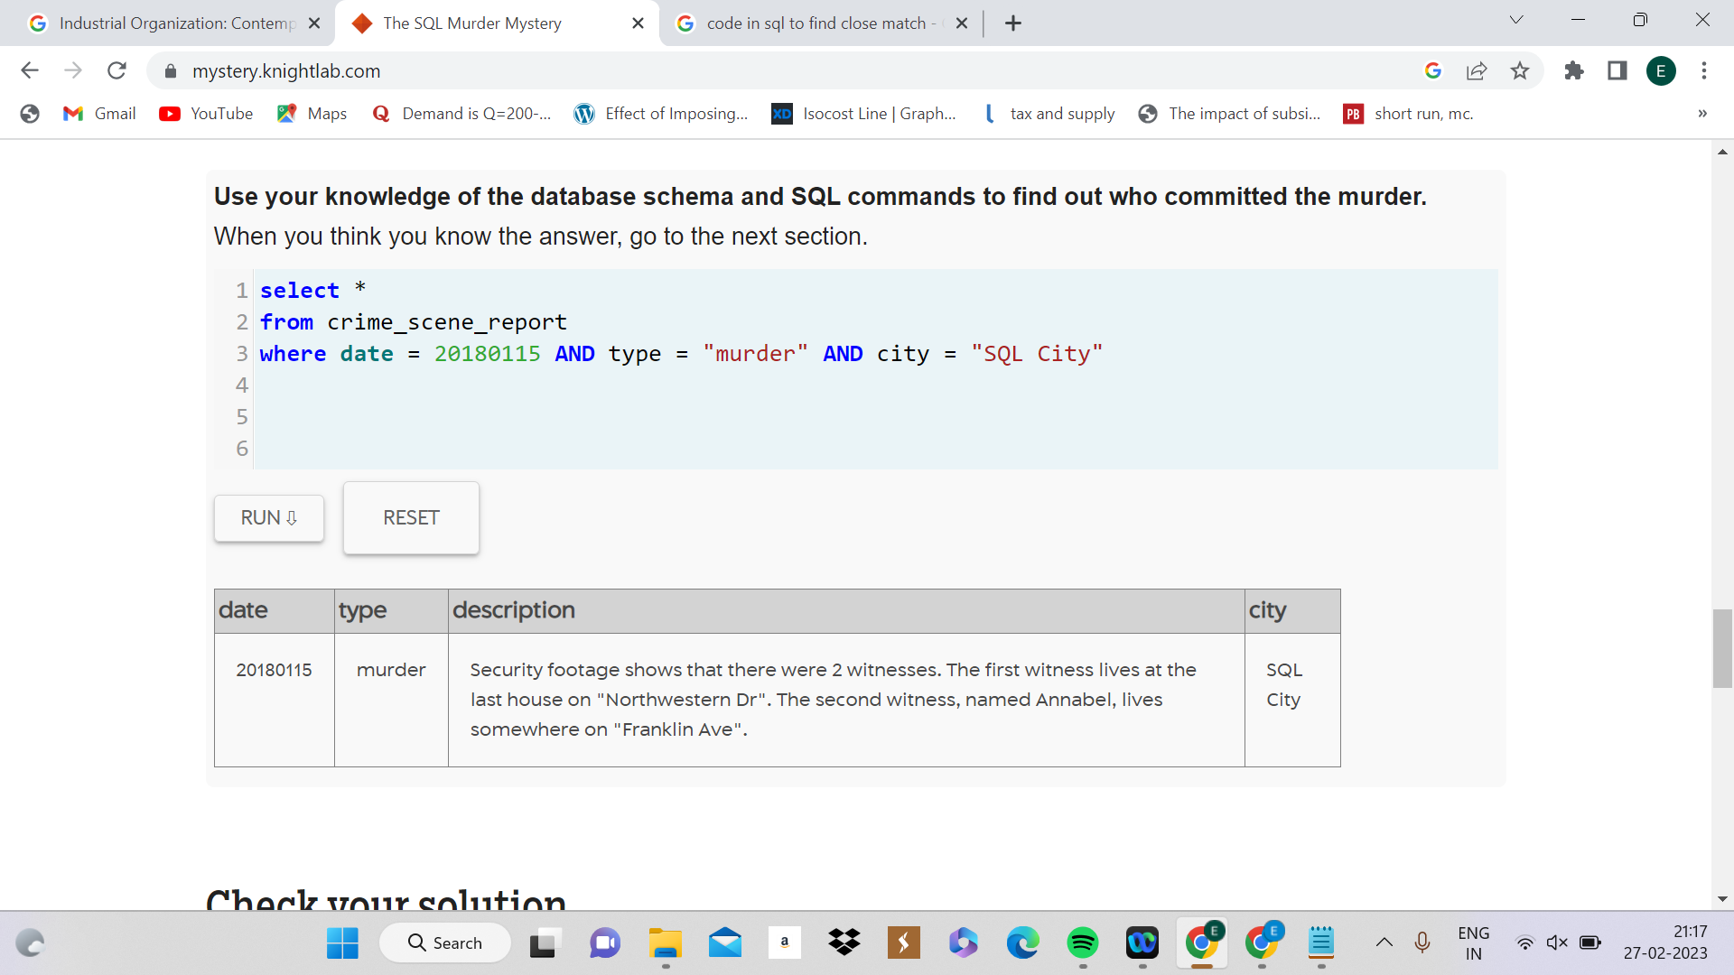

**2)Use case -** To shortlist data based on the information given.

**Query -**

select *

from person

where address_street_name = "Northwestern Dr" or name = "Annabelle"

***Result :***

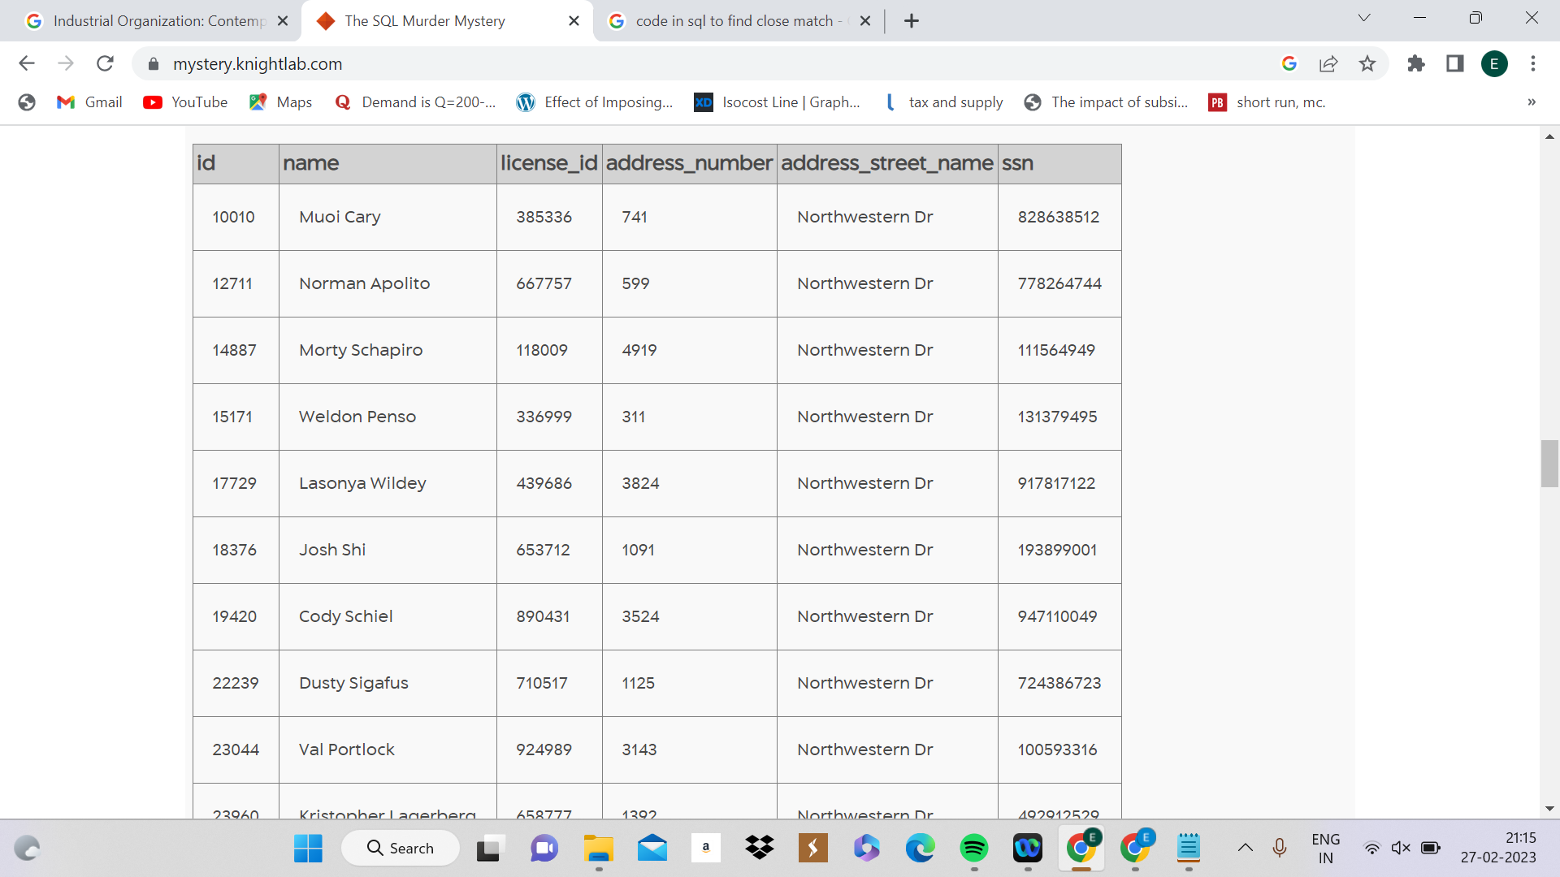

**3)Use case -**  To check all the events happening on 15th january 2018.

**Query -**

select *

from facebook_event_checkin

where date = 20180115

***Result:***

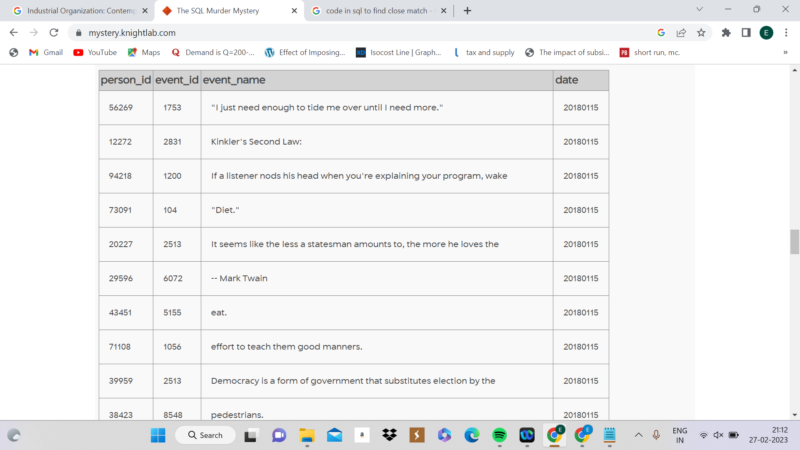

**4)Use case -** To understand if the murder was in the gym on the 15th of Ja nuary 2018.

**Query -**

select *

from get_fit_now_check_in

where check_in_date = 20180115

***Results -***

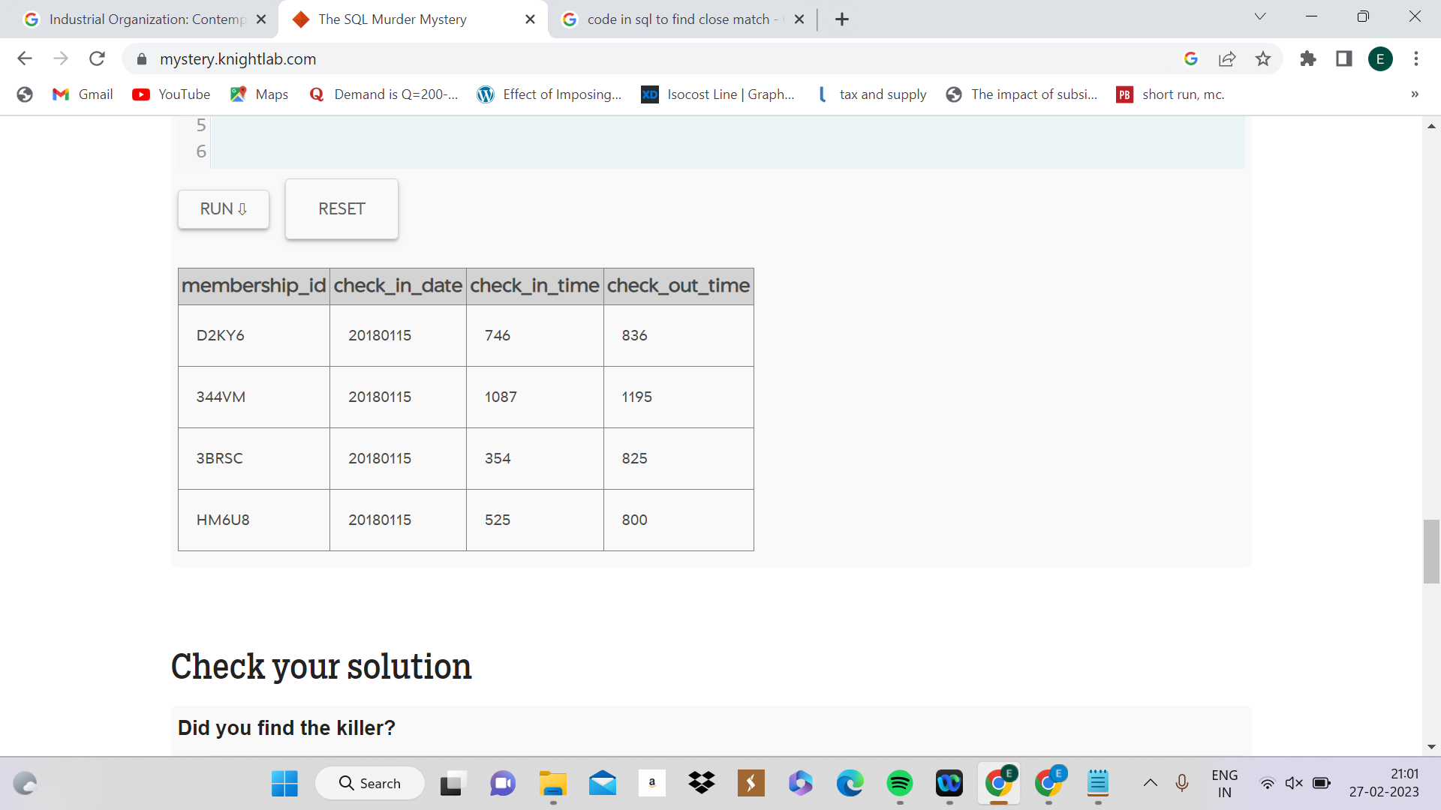

**5)Use case -**  To join two tables via the license id to get a rough idea of all the people and the compatibility between the tables.

**Query -**

select *

from person P

Join drivers_license D

ON P.license_id = D.id

***Results:***

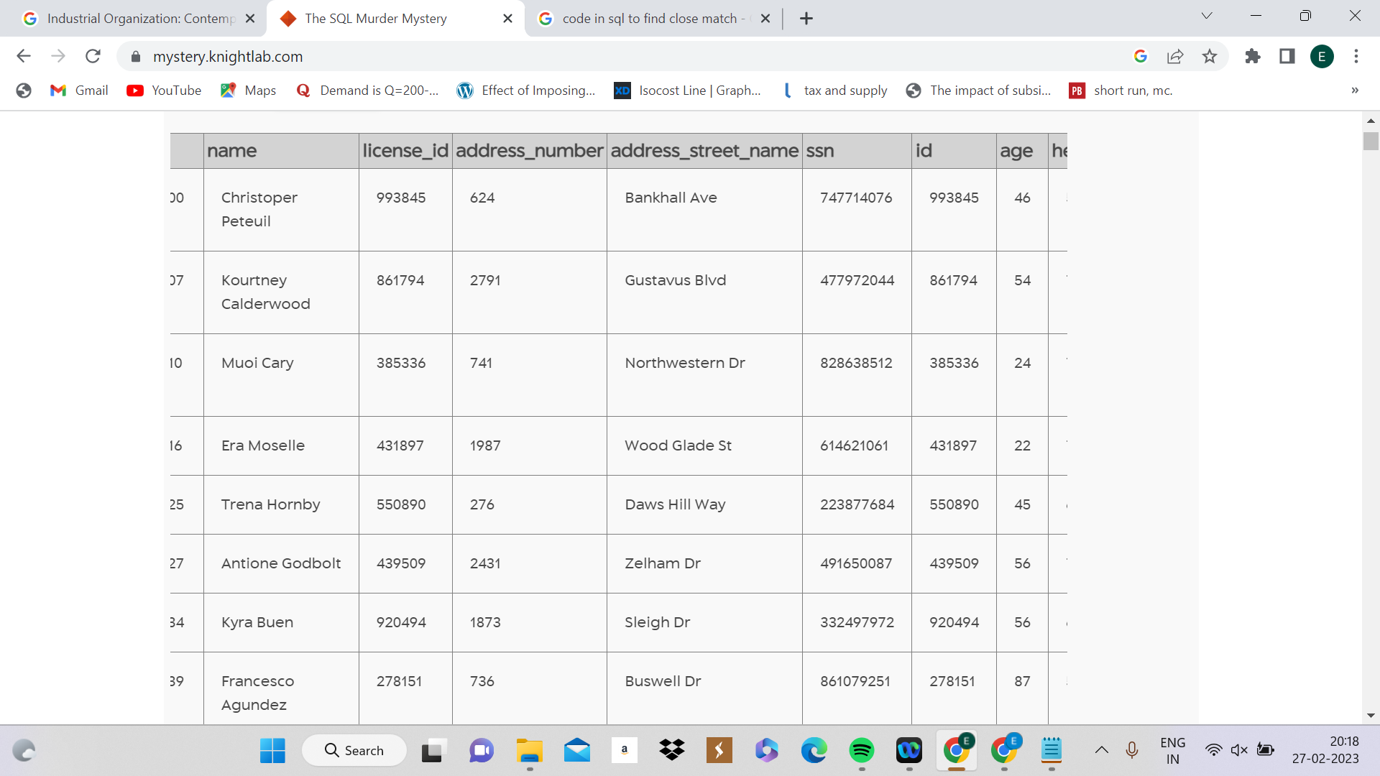

**6)Use case -** To join two tables and get the name, address, and license id of individuals living in suspected areas through the license Id.

**Query -**

select name, address_street_name, license_id

from person P

Join drivers_license D

ON P.license_id = D.id

where address_street_name in("Northwestern Dr", "Franklin Ave")

***Results:***

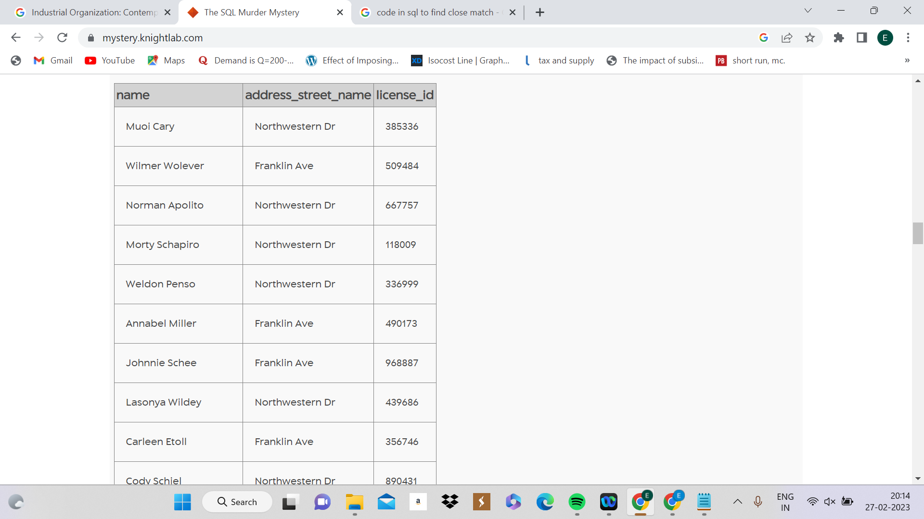

**7)Use case -** To find the id of Annabelle Miller

**Query -**

select *

from person

where name = "Annabel Miller"

***Results:***

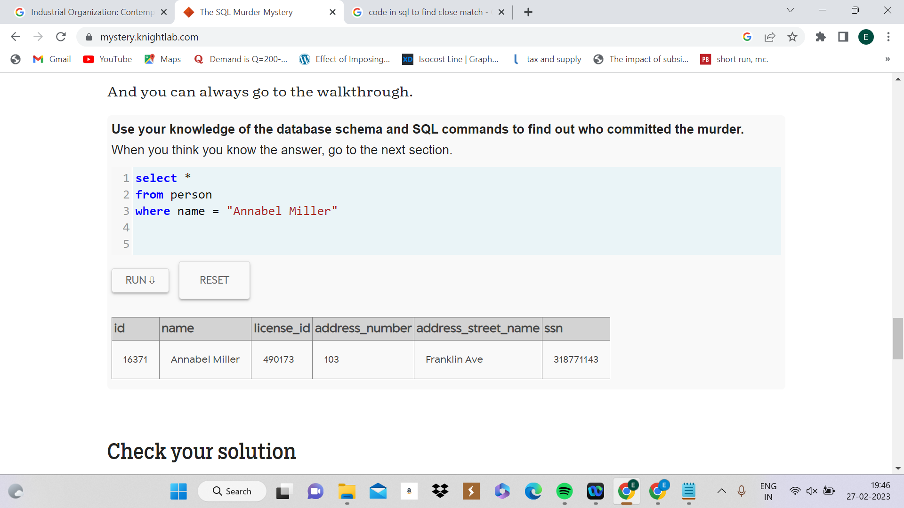

**8)Use case -** Find the name of the event that Annabelle Miller went to.

**Query-**

select *

from facebook_event_checkin

where person_id = 16371

***Result:***

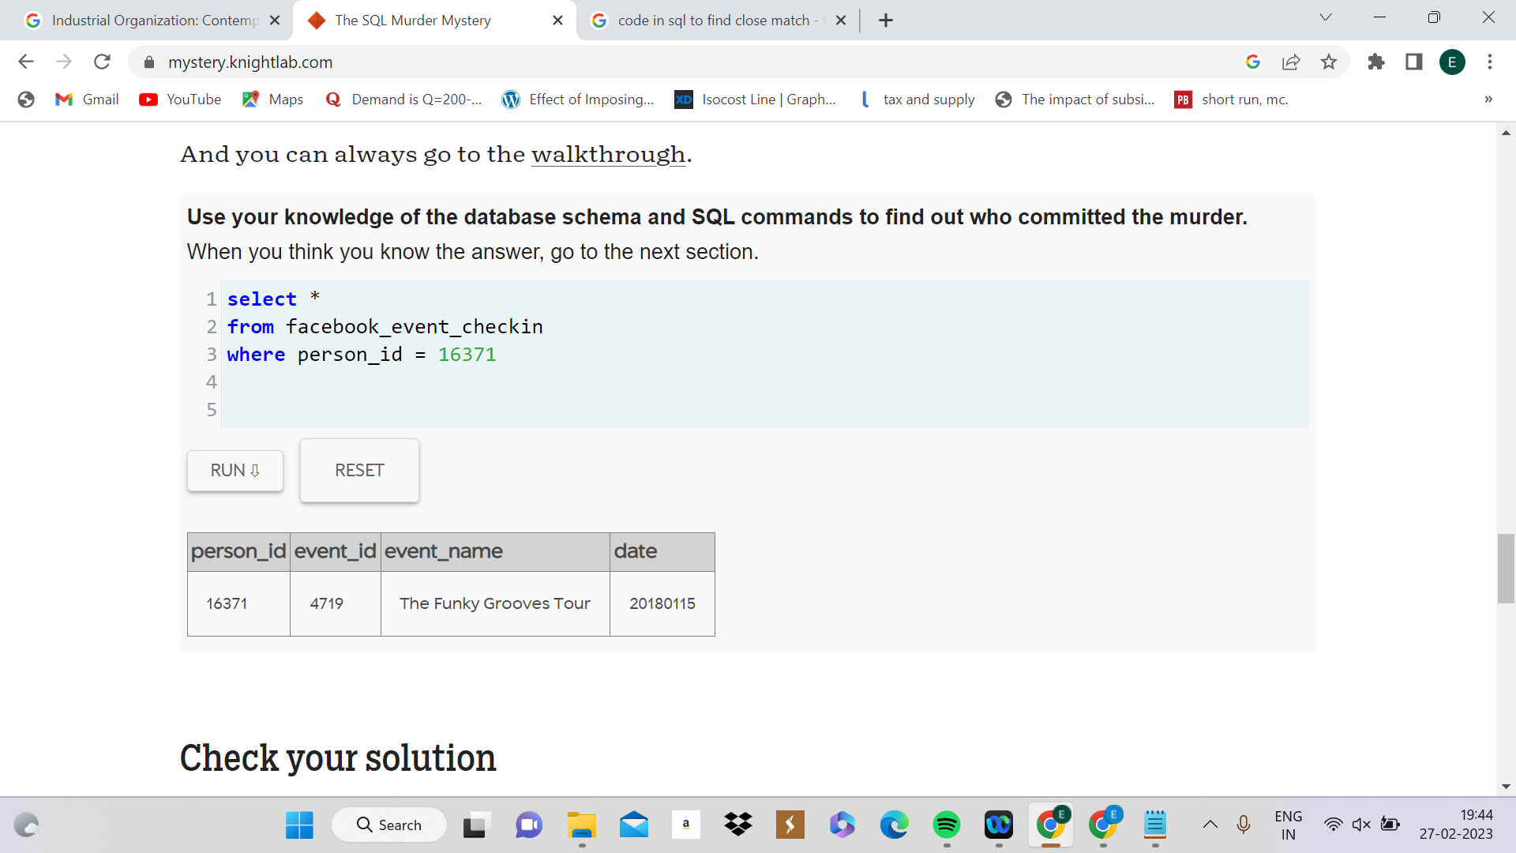

**9)Use case -** To find the id of the people who attended the given event on 15th Jan 2018

**Query:**

select *

from facebook_event_checkin

where event_id = 4719 AND date = 20180115

***Result***

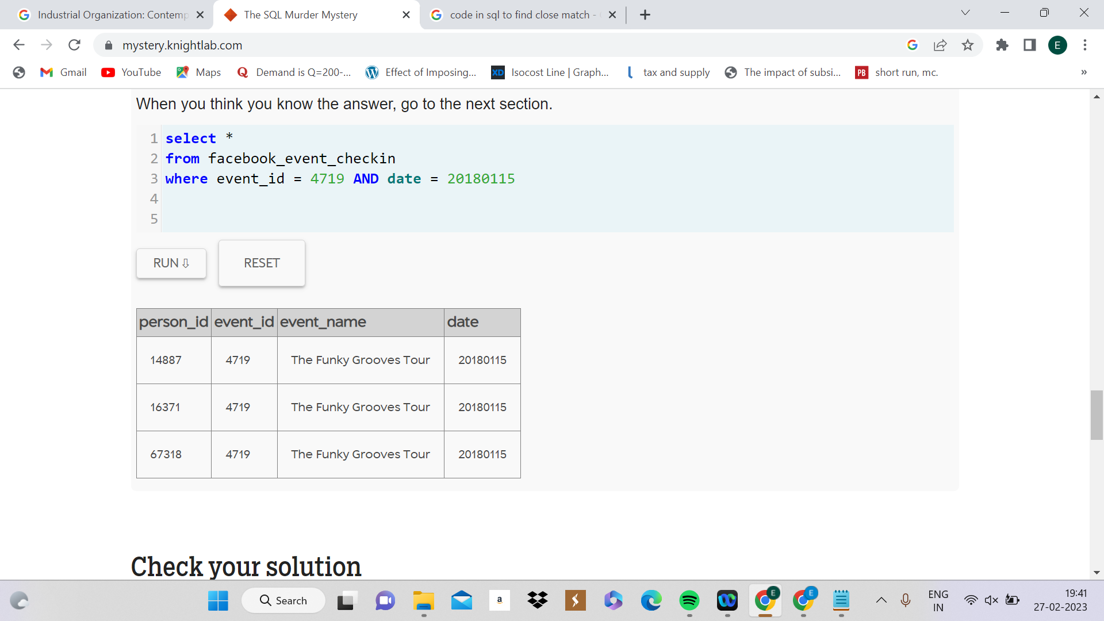

**10)Use case** - To find the name of the people with the following Id who attended the event.

**Query:**

select *

from person

Where id in(14887,16371,67318)

***Result:***

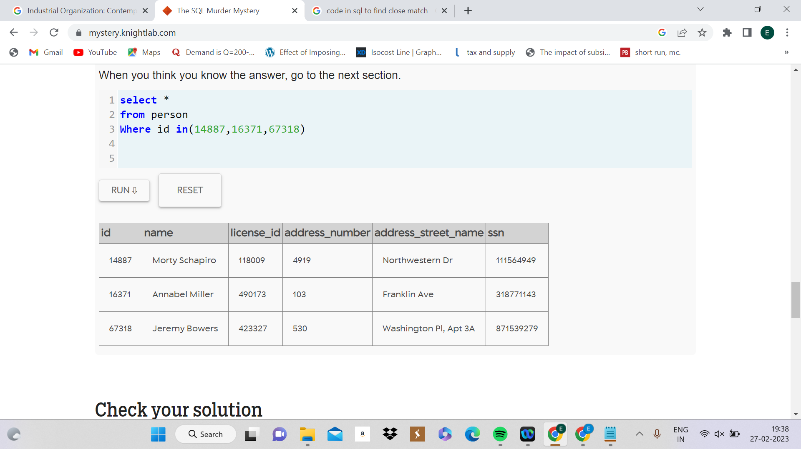

**11) Use case -** To find what statement did Jeremy bower give in his interview

**Query:**

select *

from interview

where person_id = 67318

***Result:***

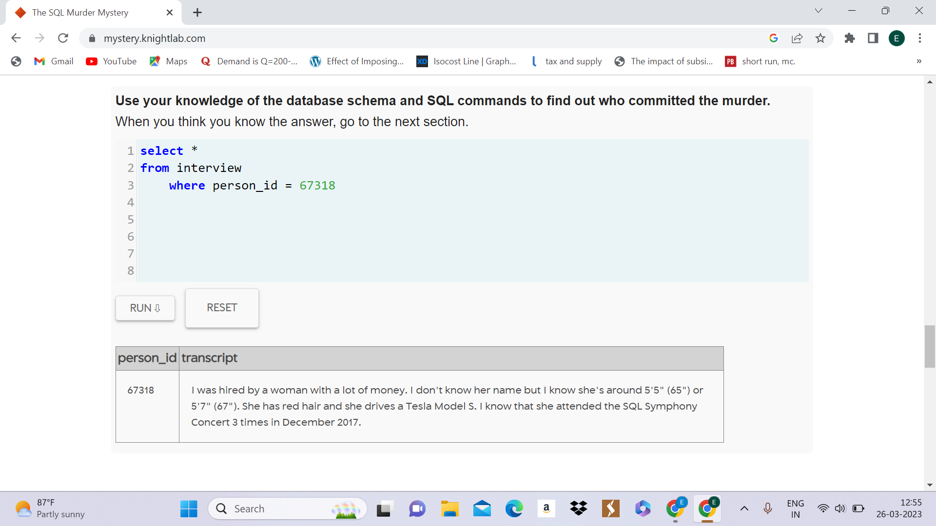

select *

from facebook_event_checkin

where date LIKE "201712%"

**12) Use case-** To identify individuals that match the description given by Jeremy in his statement.

**Query:**

select *

from drivers_license

where hair_color = "red" AND car_make = "Tesla"

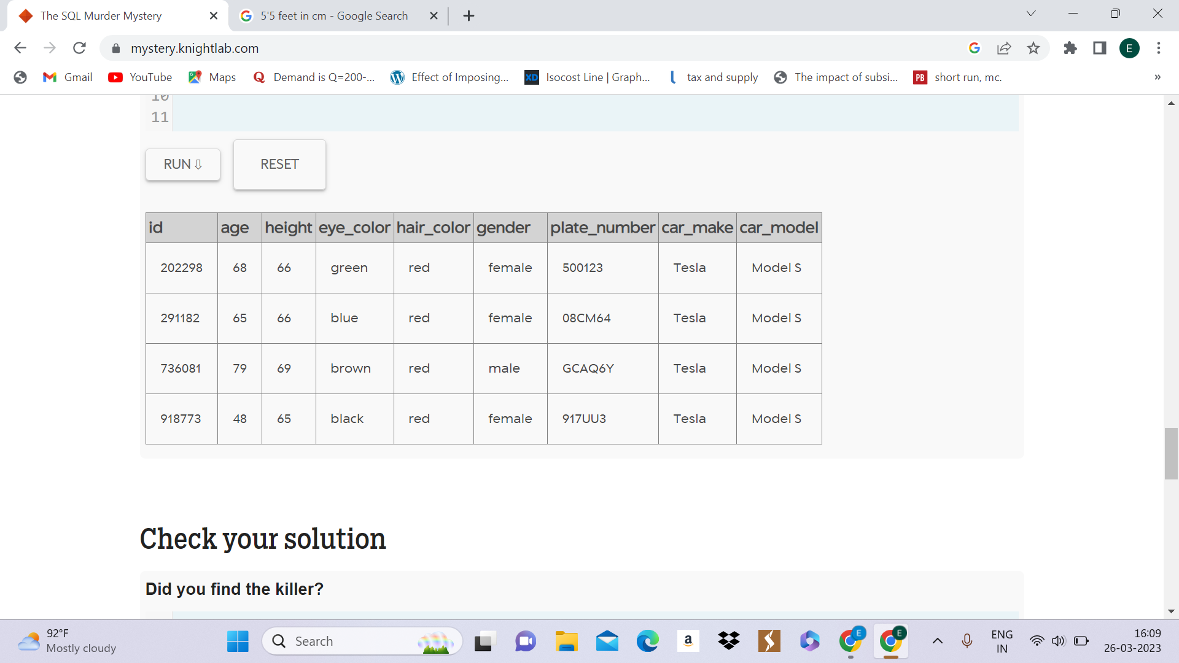

**13)** **Use case -** Joining tables to extract the details of people with red hair and a Tesla.

**Query:**

select *

from person P

join drivers_license D

ON P.license_id = D.id

where hair_color ="red" AND car_make = "Tesla"

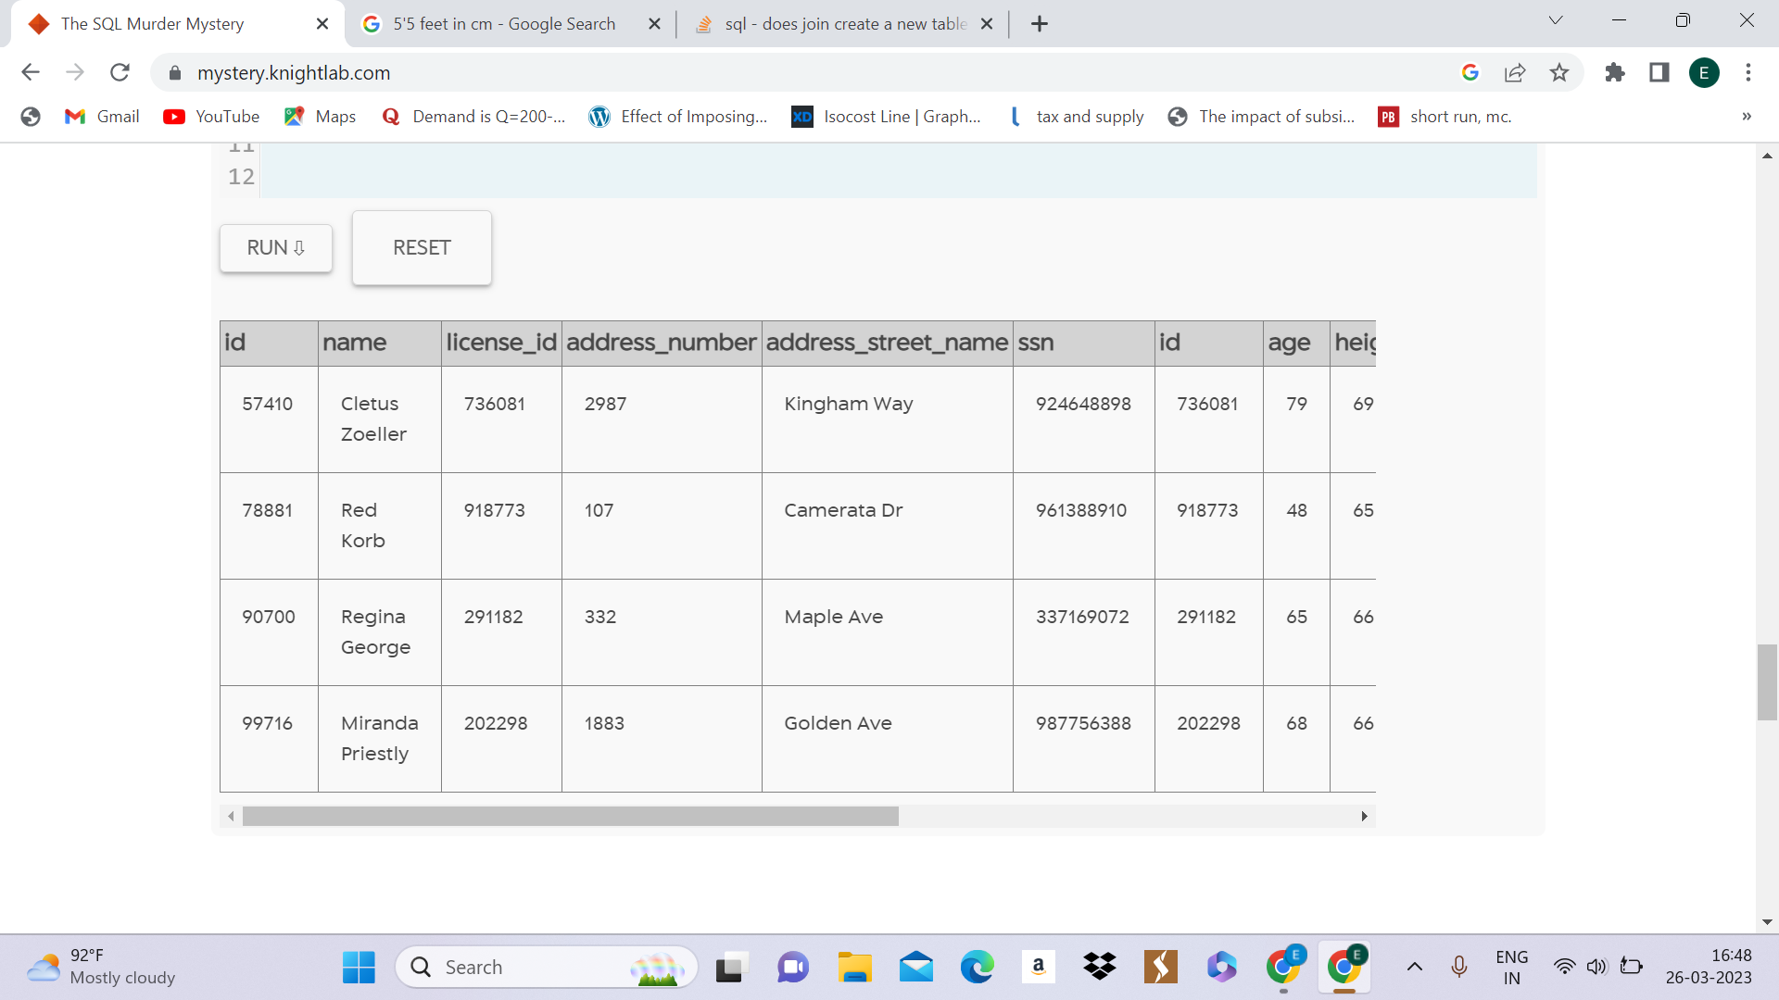

**14) Use case** - Identify individuals who visited the SQL Symphony concert in December 2017.

**Query:**

select *

from facebook_event_checkin

where date LIKE "201712%" AND event_name = "SQL Symphony Concert"

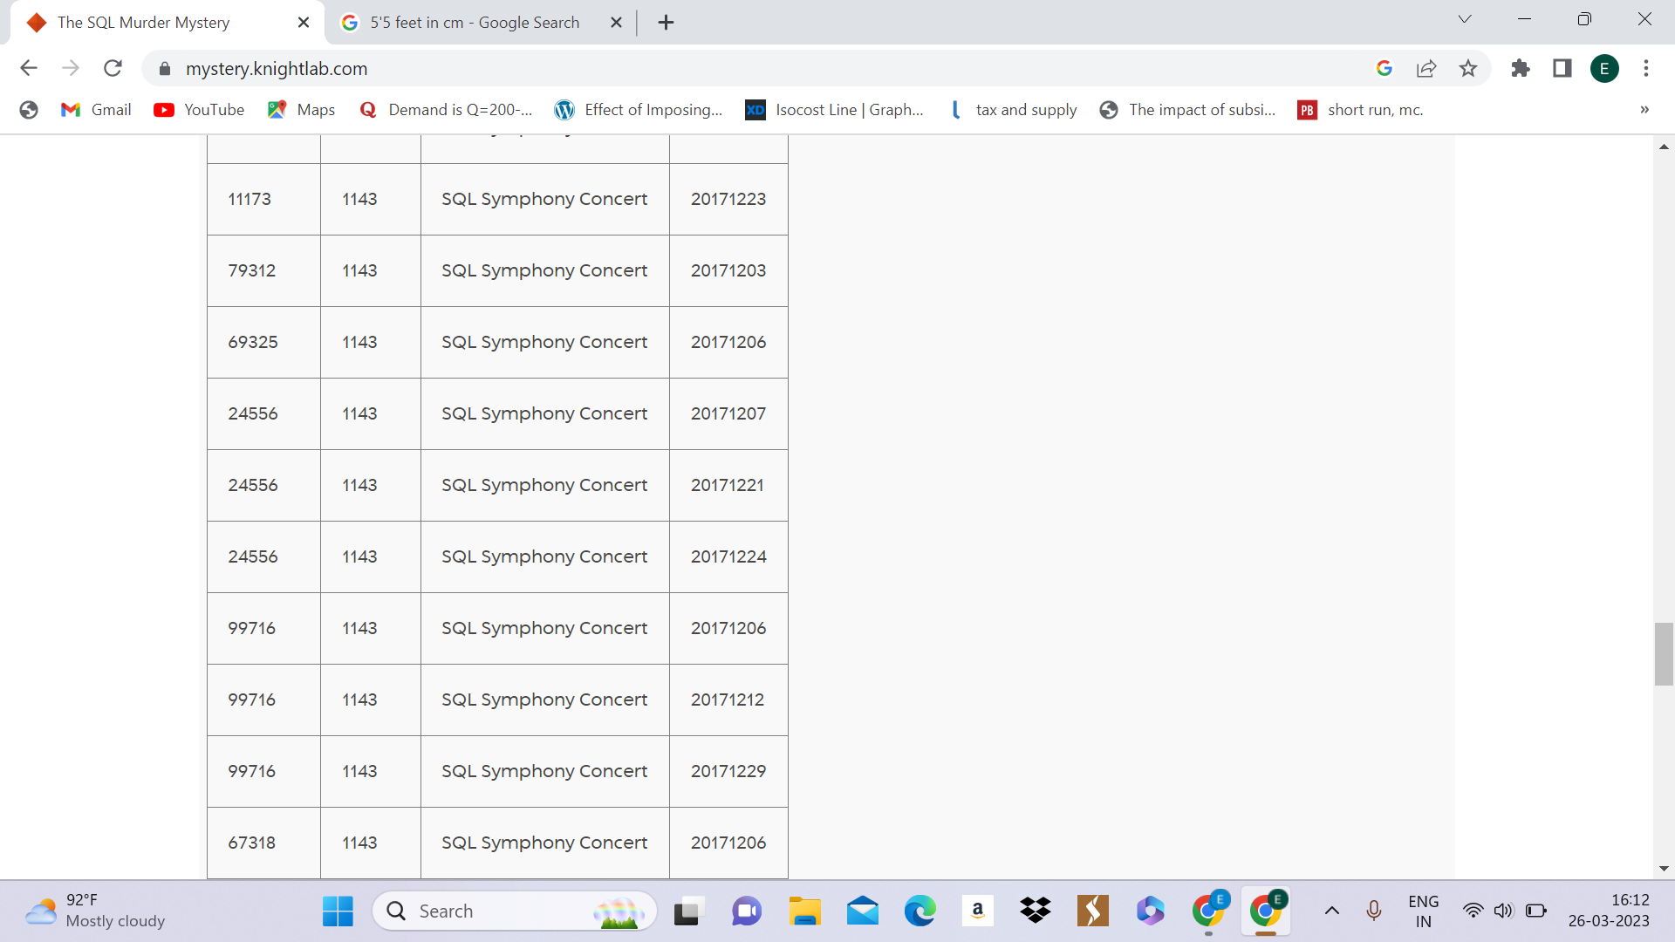

**15) Use case** - Joining tables and creating a new table called “redhair_tesla” to find the name of the person who matches the description given by Jeremy.

**Query:**

Create table redhair_tesla as

select name, address_street_name, license_id

from person P

Join drivers_license D

ON P.license_id = D.id

where hair_color = "red" AND car_make = "Tesla"

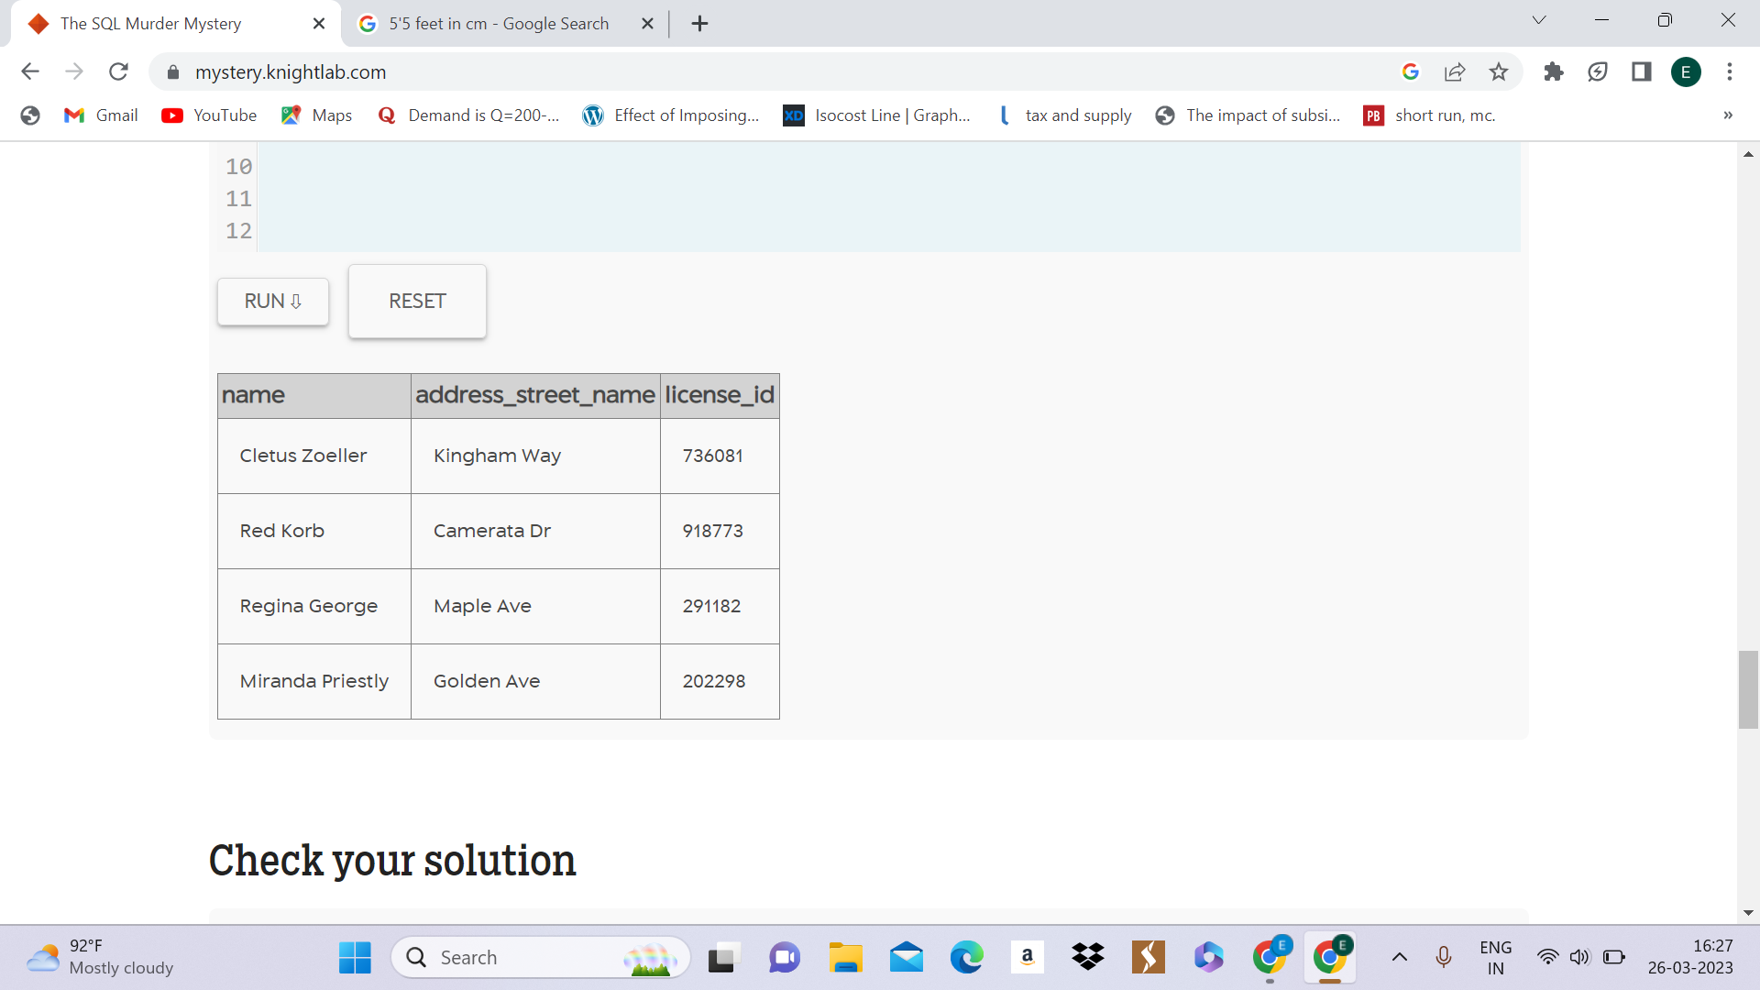

**16) Use case-** Create a new table called redhair_tesla2 by merging two more tables with more details and joining it with a new table.

**Query:**

select *

from redhair_tesla2 R

join facebook_event_checkin F

ON R.id = F.person_id

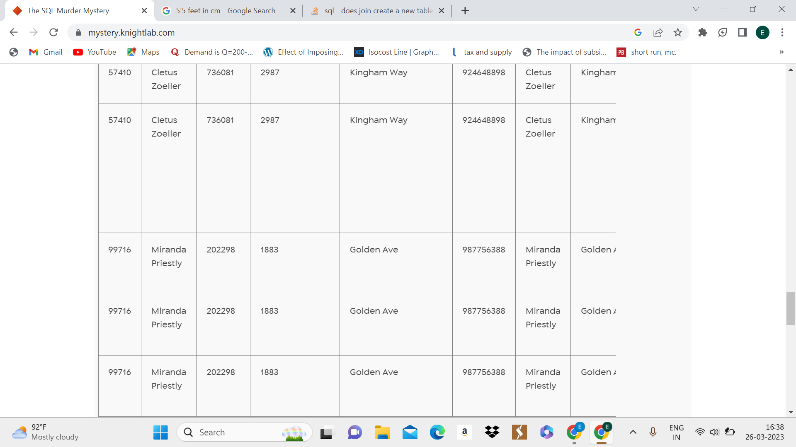

**17) Use case -** To verify who attended the SQL Symphony concert thrice.

Query:

select *

from redhair_tesla2 R

join facebook_event_checkin F

ON R.id = F.person_id

where event_name = "SQL Symphony Concert"

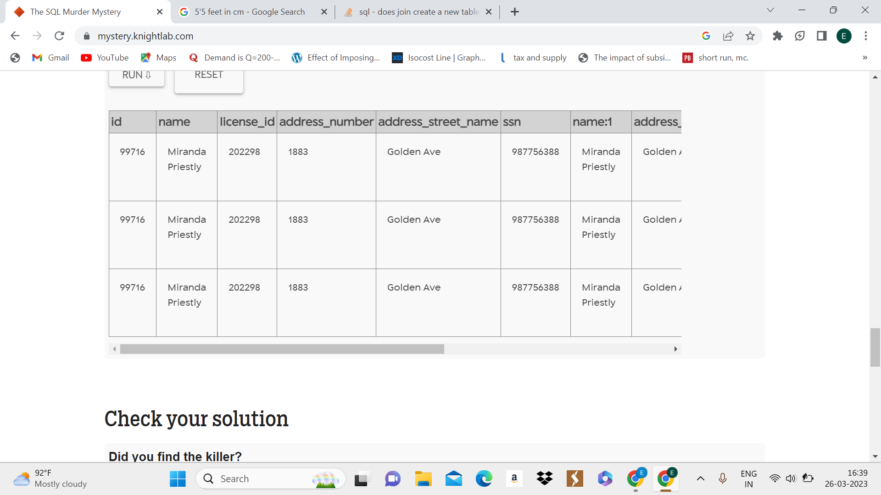

***Hence, the murderer was Jeremy bowers, who was instructed to do so by Miranda Priestly.***



CAUGHT YOU!